Electrical summer task-1

Stm32 line is a whole family of 32 bit ARM microcontrollers is from STMicroelectronics.

32bit microcontrollers are cheap as 8 bit microcontrollers and offer a lot more power.

They have two units on STM32. They are MCU(microcontroller units) and MPU (microprocessor units). STM has broken down MCU’s based on needs as high performance, mainstream, ultra low power and wireless MCU’s. In that high performance MCU’s they have classified them based on architecture like ARM CORTEX M3,M4 and M7. STM32F401 is a microcontroller which is of ARM CORTEX M4 core.

STM32F401RET6 is in the LQFP64 package(It’s shown below).

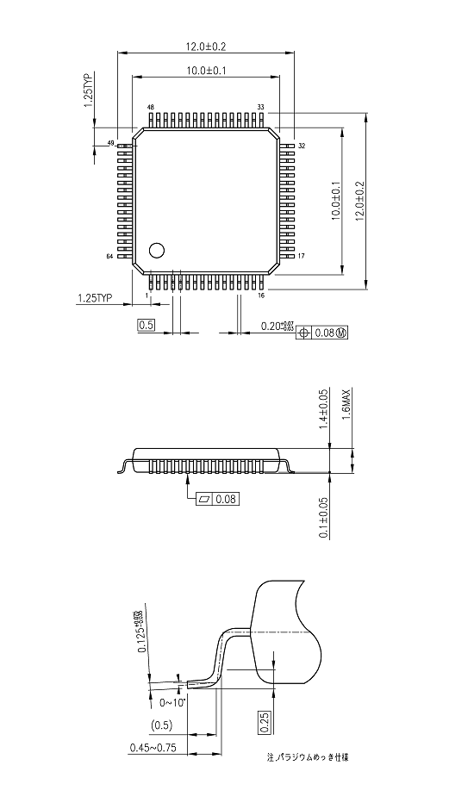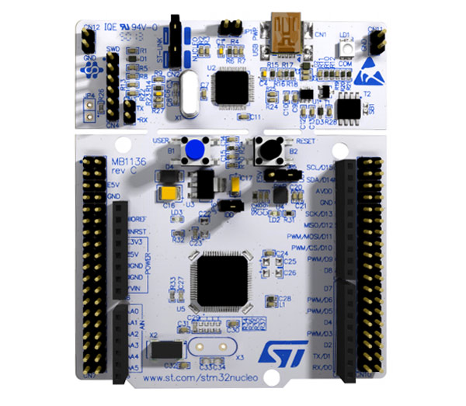

STM didn’t stop with microcontrollers they also made development boards similar to Arduino, raspberry pi, etc.. with additional pins and using these microcontrollers which are called nucleo boards.

This is a STM32 Nucleo F401RE Development Board. Picture in the above is called nucleo board.

It features the ARM cortex M4 32-bit STM32F401RET6 microcontroller which is in LQFP64 package. It is similar to Arduino UNO and has many other additional pins to expand performance. It comes with an integrated ST-LINK/V2-1 programmer and debugger. It has CPU frequency of 84 MHz and crystal oscillator range is from 2 MHz to 26 MHz. MCU operating voltage is 1.7v to 3.6v and the Board operating voltage is 7v to 15v. It has flash memory of 512kb and ram of 96kb. It has a 12bit 16 channel ADC(Analog to Digital converter). It has RTC(Real time clock) in-built 32KHz with calibration. It has timers of 16-bit(6),32-bit(2) and watch dog timer(2). It has communication ports for USART/UART (4), I2C(3) and SPI(3). Has a USB2.0 support. It has 50 GIPO pins.

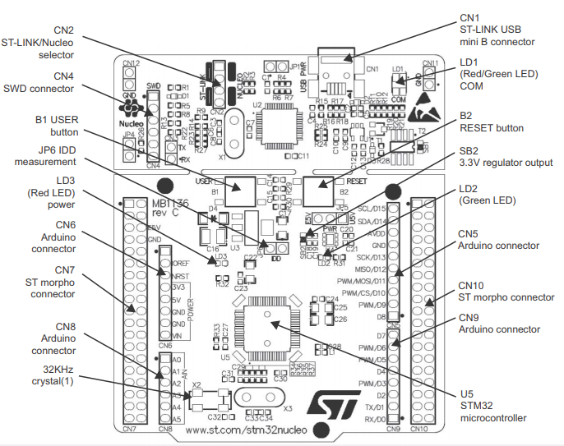

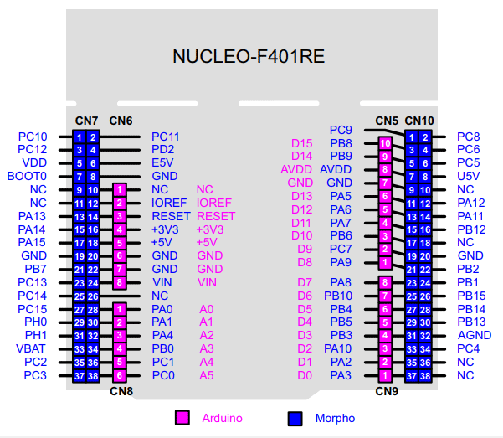

a) This is pin out diagram of that nucleo board. It has two set of pins one Arduino(pink shaded) and the other is STM32 GIPO pins(blue shaded). Arduino pins are female connectors and there are in exact position like Arduino uno so that we can use any type of Arduino shields on these development boards.

CN6 (power pins) Arduino connector:

IOREF 3.3v reference voltage pin

RESET resets the microcontroller

+3.3v gives 3.3v as output

+5v gives 5v as output

GND Ground pins

CN8 (Analog pins and I2C) Arduino connector:

A0-A3 Used to measure analog voltage and ADC A4-A5 It can also be used for I2C communication and A4 is SDA and A5 is SCL; ADC.

CN5 (Digital GIPO pins) Arduino connector:

D15-D14 I2C

D13 SPI1\_SCK

D12 SPI1\_MISO

D11 TIM1\_CH1N or SPI1\_MOSI

D10 TIM4\_CH1 or SPI1\_CS

D9 TIM3\_CH2

D8 -- (Normal GIPO pin)

CN9 (Digital GIPO pins) Arduino connector:

D7 -- (Normal GIPO pin)

D6 TIM2\_CH3

D5 TIM3\_CH1

D4 -- (Normal GIPO pin)

D3 TIM2\_CH2

D2 -- (Normal GIPO pin)

D1 USART2\_TX

D0 USART2\_RX

Apart from these Arduino pins they have 76 (38+38) pins on the either side of the board. Those are CN7 and CN10 with each 38 pins. Those are GIPO pins, analog pins, Digital pins, timer pins and power pins. Those are classified below.

CN7 (Port pins)

PC0-PC3 & PC10-PC15 Port c digital i/o pins

PD2 Port D i/o pin

PA0, PA1, PA4, PA13-PA15. Port A i/o pins

PB7, PB8 and PB9 Port B i/o Pins

PH0 and PH1 Port H i/o pins

Power VBAT Used to power the module using the battery

+3.3V provides 3.3 as output voltage and can be used

to power the MCU.

+5V Provides 5v as output.

VIN Unregulated input power pin

RESET Resets the MCU

IOREF Reference voltage pin

CN10 (port pins)

PC4-PC9 Port c i/o pins

PA2, PA3, PA4, PA6, Port A i/o pins

PA7, PA10, PA11 and PA12

PB1, PB2, PB3, PB4, PB5, PB6, Port B i/o pins

PB8, PB9, PB10, PB12, PB14, PB15

Power 5V power pin

GND System Ground of the MCU

AGND Analog Ground Pin

b) STM32 Vs Arduino

The processor

Arduino Uno is based on ATMega328P, an 8bit BUS core with AVR advanced RISC architecture able to perform 1MIPS per MHz made my ATMEL while STM has its own processor on the board, which is based on ARM architecture, an 32 bit BUS core able to perform 1.25 DMIPS per MHz. STM has higher clock frequency, larger memory and other additional interfaces. Arduino has EEPROM memory where it can be written by the program to permanently store data but STM don’t have EEPROM, they have a flash memory that is accessible by both microcontroller and the user (by a USB cable). So the STM32F401 ARM architecture perform better than ATMega328P when compared.

I/O pins and interfaces

Arduino has 23 i/o pins that can be used by the user. The Nucleo has from 36 up to 81 pins (all 5v tolerant) i/o pins which roughly correspond to an Arduino mega. Arduino has 6 to 8 (10bit) ADC while STM has 16(12bit) ADC. Arduino has less no. of I2C, SPI, UART pins compared to has STM32. so from above we can see that STM32 is better.

Energy consumption and voltages

Both the boards have USB connection and VIN pin to power the board. In the VIN pin the voltage is adjusted with a voltage regulator and supplied for the other components in the board. When we supply 6v in VIN, the idle current consumption for Arduino was 25.6 mA and for Nucleo 40.8mA. Atmel ATMega328P takes generally 1.8v to 5.5v while STM32F401RE takes 1.7v to 3.6v.

Storage

The Nucleo is has more memory compared to Arduino. If it comes to small projects Arduino is completely sufficient. RAM in Arduino is 2KB while in STM32

Nucleo is 128KB. Flash memory in Arduino is 32KB while in STM32 Nucleo is 512KB.

Arduino has EEPROM but STM32 don’t have.

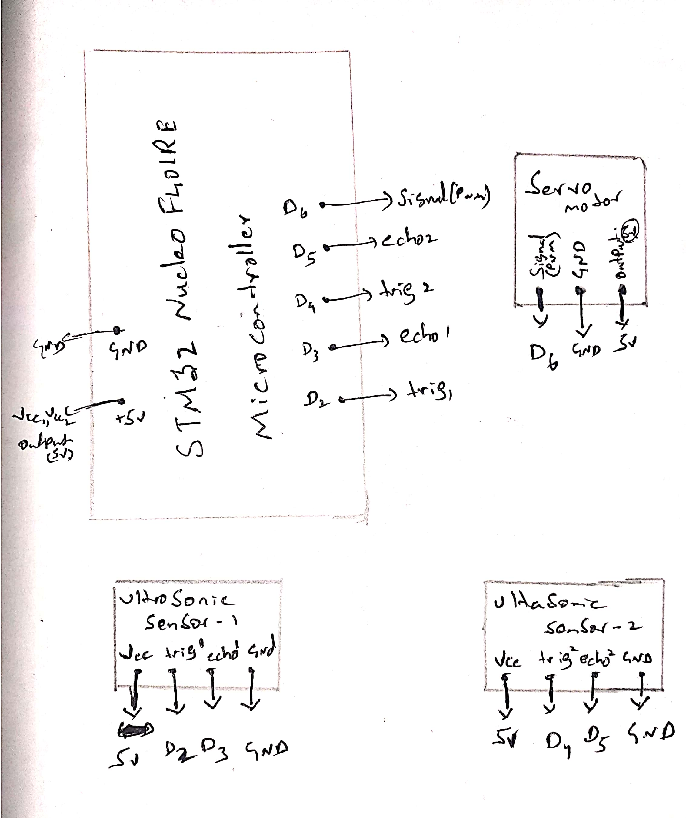

Robot operating system (ROS) is a collection of software frameworks for robot development. It is not an operating system but it provides the services that we expect from an operating system including hardware abstraction, low-level device control, implementation of commonly-used functionality, message-passing between processes and package management. It also provides tools and libraries for obtaining, building, writing and running code across multiple computers. It’s even said as Meta operating system. A Meta Operating system has a huge amount of functionality, so much that it cannot be classified as a framework or a cluster of libraries but not so much that it can be categorized as an operating system either. It provides functionalities of both Operating Systems as well as frameworks but not fully hence, it cannot be classified as either e.g, it does not provide the core functionalities that an operating system is supposed to provide but provides APIs.

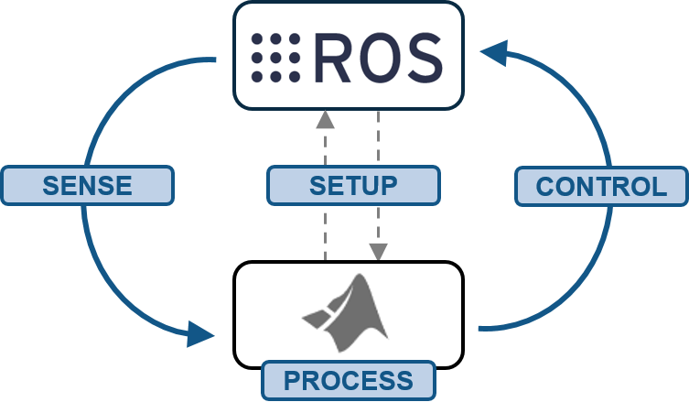 It runs on the existing Operating system. It describes a system that performs processes such as scheduling, loading, monitoring and error handling by utilizing virtualization layer between applications and distributed computing resources. In order to operate ROS we must have OS of one of Linux’s distributions must be installed in system. ROS is a supporting system for controlling a robot and sensor with a hardware abstraction and developing robot application based on existing conventional operating systems.



Mbed programming :

a) #include "mbed.h"

Serial pc(USBTX, USBRX);

//For ten’s led output

DigitalOut Led\_01(PB\_8);

DigitalOut Led\_02(PB\_9);

DigitalOut Led\_03(PA\_5);

DigitalOut Led\_04(PA\_6);

DigitalOut Led\_05(PA\_7);

DigitalOut Led\_06(PB\_6);

DigitalOut Led\_07(PC\_7);

DigitalOut Led\_08(PA\_9);

DigitalOut Led\_09(PA\_8);

//for one’s led output

DigitalOut Led\_11(PB\_10);

DigitalOut Led\_12(PB\_4);

DigitalOut Led\_13(PB\_5);

DigitalOut Led\_14(PB\_3);

DigitalOut Led\_15(PA\_10);

DigitalOut Led\_16(PA\_2);

DigitalOut Led\_17(PA\_3);

DigitalOut Led\_18(PA\_0);

DigitalOut Led\_19(PA\_1);

int main()

{

while(1)

{

char Tens\_array[]={'Led\_01','Led\_02','Led\_03','Led\_04','Led\_05','Led\_06','Led\_07','Led\_08','Led\_09'};

char ones\_array[]={'Led\_11','Led\_12','Led\_13','Led\_14','Led\_15','Led\_16','Led\_17','Led\_18','Led\_19'};

int fib[]={0,1,1,2,3,5,8,13,21,34,55,89};

int n=pc.getc();

int tens,ones,f;

f=fib[n];

tens= f/10;

ones= f%10;

for(int i=0; i<tens; i++)

{

Tens\_array[i]=1;

}

for(int i=0;i<ones;i++)

{

ones\_array[i]=1;

}

}

}

b) #include "mbed.h"

#include "Servo.h"

Servo servo1(PA\_5);

Servo servo2(PA\_6);

Serial pc(USBTX, USBRX);

int main()

{

while(1)

{

while(pc.readable()>0)

{

char a= pc.getc();

for(int i=0; i<a; i++)

{

servo1=i;

wait(0.01);

}

for(int i=0; i<(180-a); i++)

{

servo2=i;

wait(0.01);

}

wait(0.1);

}

}

}

Automation in agriculture

Lidar (light detection and ranging) is an optical remote-sensing technique that uses laser light to densely sample the surface of the earth, producing highly accurate x,y,z measurements. Lidar, primarily used in airborne laser mapping applications, is emerging as a cost-effective alternative to traditional surveying techniques such as photogrammetry. Lidar produces mass point cloud datasets that can be managed, visualized, analyzed, and shared using ArcGIS. LiDAR technology is one of the most advanced and most accurate technologies in the GIS system. Its uses cut across several industries with various professionals and institutions relying on LiDAR data for information. One such industry is agriculture. LiDAR is used extensively for various reasons in the agricultural sector. A Bot or drone with LiDAR can do the Following.

**1. 3D modeling**

LiDAR technology is instrumental in developing 3D models of a farm land and helps come up with accurate maps of the natural resources around that area. With this data, the farmer can then be able to discern the exact terrain of the farm and identify the water catchment area and the flow of erosion. LiDAR data can be used for planning and management of agricultural farms. Using this technology, the farmer can be able to know the suitability of land for a particular crop and the best time to plant.

**2. Determination of soil type and crop, soil analysis**

LiDAR technology can also be used to collect data that can identify the exact soil type that a certain farmland has. This information is important to the farmer because it helps the farmer know which type of crops can be grown on that farm and what fertilizer should be applied. LiDAR can also be used to carry out general crop analysis and determine the suitability of the crop to thrive in a particular area. This can be done through estimation of the crop quality and measuring this against the ideal standards. Experts have been able to use the LiDAR technology to analyze soil content and soil type to determine its suitability for crop production. In several cases, they have been able to understand why certain types of soil do not lead to much crop yield and what to do about it.

### 3. Precision Agriculture

LiDAR data is instrumental in precision agriculture. Precision agriculture is the planning of a particular farm site with the intention of increasing the productivity of this site by improving overall yields.

### 4. Land mapping

LiDAR data can also be used to map a farmland and come up with the exact design and map of the land. This data will also include the shape and terrain of the farmland. With this data, farmers will be able to know what to plant and how to plant crops on that farmland.

### 5. Yield Forecasting

LiDAR data has been used in forecasting the expected yields from a farm. This data generated by this technology helps farmers know the suitability of a particular crop on a given land based on the expected returns of the yields at the end of the season.

**6. Determination of soil type and Prevention of soil erosion**

Experts have been able to determine the soil type of a particular area. The data collected has the ability to generate the exact soil type and the soil content. Experts can then use this data to advise farmers on the best possible farming practice. LiDAR technology has been instrumental in preventing soil erosion through 3D mapping and modeling of a given farmland. By getting the exact terrain of the farm and knowing the contours of a farm, farmers are able to come up with preventive measures to reduce or eliminate soil erosion.

**7. Land segmentation**

Another important use of LiDAR in agriculture is land segmentation. Through LiDAR technology, experts have been able to interpret the data to show the land patterns and use the information to segment the land for different uses.

**8. Field Management**

LiDAR data can also be used to provide general field management services. These may include services like irrigation and the amount of water required to irrigate or how many times in a year a crop should be planted on a given farmland

### 9. Controlling crop yield

LiDAR technology can also be used to control the overall crop yield in a given season. This can be done through precision agriculture where a farmer can predict the crop yield and implement measures to increase the overall yield.

### 10. Production Zones

LiDAR can also help experts in identifying potential production zones in an area. The data collected through this technology can help select an area in your farm land where production is likely to be higher than the rest of the land.

### 11. Crop damage

LiDAR technology can be used to determine the extent to which crops in an area have been damaged and the cause of the damage. This can help farmers come up with mechanisms to prevent the damage and hence increase yields.

These are the conclusions when we use LiDAR in farmland. A further exploration can give out best and efficient. An example of such is  [EarthSense](https://www.earthsense.co/home/" \t "_blank)’s TerraSentia rover is about the same size as a robotic lawnmower, but souped-up with the machine learning and visual programming of NASA’s moon and Mars rovers. 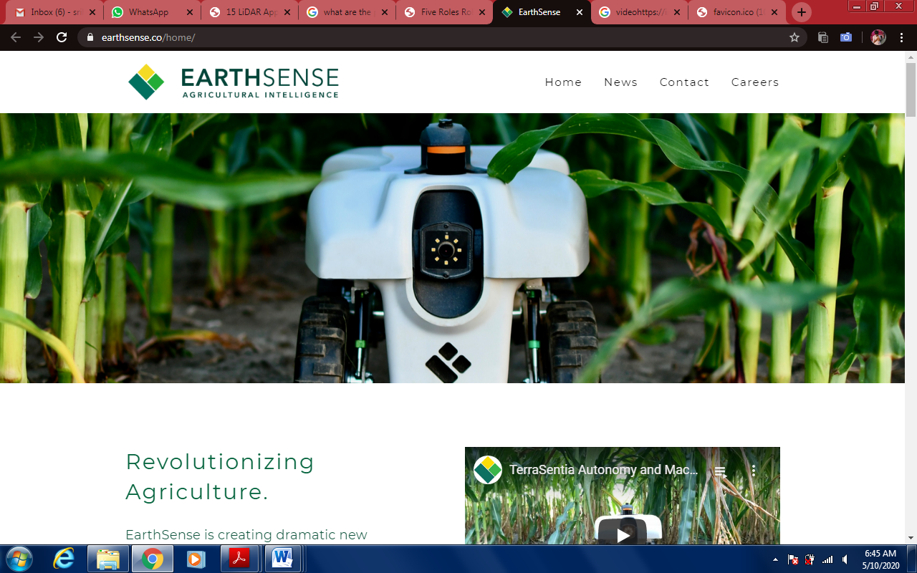

In fact, TerraSentia, developed at the University of Illinois at Urbana-Champaign with support from the U.S. Department of Energy’s ARPA-E, uses LiDAR—or light detection and ranging—technology to collect data from a field’s hard-to-reach understory. It’s a simpler version of the technology that NASA is using on its rovers to [study the surface of the moon and Mars](https://appel.nasa.gov/2019/07/25/nasa-testing-new-technology-to-aid-moon-landing/) and that deep-sea remotely operated vehicles use to [study the ocean floor](https://annualreport.mbari.org/2018/story/visualizing-the-fine-details-of-the-deep-seafloor). Combined with other on-board technology systems, TerraSentia can “collect data on traits for plant health, physiology, and stress response,” according to the [EarthSense website](https://earthsense.co/home/" \t "_blank). Its creators hope to soon program the bot to measure young plant health, corn ear height, soybean pods, plant biomass as well as detect and identify diseases and abiotic stresses, according to the site. So far, it’s been deployed in corn, soybean, wheat, sorghum, vegetable crops, orchards, and vineyards.

Video Link: https://youtu.be/Dc63XGDj2SU

-J sri balaji (19BEC11170)